Database Fundamentals

TOPICS COVERD IN THIS DOCUMENT :
- What is a Database
- DBMS vs File System
- Advantages of DBMS
- Data Abstraction
- Three Schema Architecture
  - External
  - Conceptual
  - Internal
- Data Independence
  - Logical
  - Physical

What is Database?

Data refers to raw, unorganized facts and figures, such as numbers, text, images, or symbols, that can be processed and analyzed to extract meaningful information
- Data can exist in a raw form (unorganized) or processed form (organized and meaningful).
- A database is a structured collection of data designed for efficient storage, retrieval and manipulation.
- It serves as a centralized repository, allowing data to be accessed, managed, and updated by multiple users or applications

A high-performing database is vital for any organization, supporting operations, customer interactions and systems like digital libraries, reservations, and inventory management. Databases are essential because they:
- Scale efficiently to handle massive volumes of data.
- Ensure data integrity through built-in rules and constraints.
- Protect data with secure access controls and compliance support.
- Enable analytics by identifying trends and guiding informed business decisions.

Working of Databases
Databases work by organizing and storing information in a structured or unstructured format, allowing easy access, retrieval, and modification. At the core of every database system is the Database Management System (DBMS)—a software layer that acts as an intermediary between users and the raw data.
- The DBMS handles tasks like querying, updating, deleting and managing access permissions, without requiring users to know the physical details of where data is stored.
- When a user submits a request (such as a search or update), the DBMS processes the query, locates the relevant data, and returns results in a structured format.
- DBMSs provide features like backup, recovery, performance optimization and data security to ensure the system runs efficiently and reliably.

According to industry rankings, the most popular databases of 2025 are:

Components of a Database
Databases consist of several critical components that work together to store, organize and retrieve data effectively. Here is a detailed explanation of each component:
- Data: The actual information stored in the database, such as text, numbers, images, or files.
- Schema: The structural blueprint that defines how data is organized—tables, fields, data types, and relationships.
- DBMS: The software that manages database operations like storage, retrieval, and security (e.g., MySQL, Oracle).
- Queries: Instructions (usually SQL) used to retrieve or manipulate data within the database.
- Users: People or systems that interact with the database, each with specific roles and access permissions.

Types of Databases
Databases can be classified into two primary types Relational (SQL) and NoSQL Databases. NoSQL is then further divided into four types: Document-oriented, Key-Value, Wide-Column, and Graph databases.

1. Relational Databases (RDBMS)
Relational databases organize data into tables made up of rows (records) and columns (fields). They use schemas (blueprints) to define how data is structured and how different tables relate to each other.
- Strict schema-based structure.
- Primary Keys (unique IDs) and Foreign Keys (relationships between tables).
- Strong ACID compliance (Atomicity, Consistency, Isolation, Durability).
- Ideal for structured data.
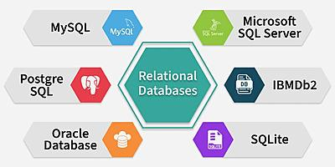
Examples: MySQL, PostgreSQL, Oracle, Microsoft SQL Server.

2. NoSQL Databases
"NoSQL" stands for "Not Only SQL". These databases are designed to handle unstructured or semi-structured data, such as text, images, videos or sensor data. They don’t rely on the traditional table format.
- Flexible data models (no fixed schema).
- Scales horizontally for high-volume data.
- Often optimized for specific use cases like graphs or time-series data.
Main Sub-Types of NoSQL Databases:
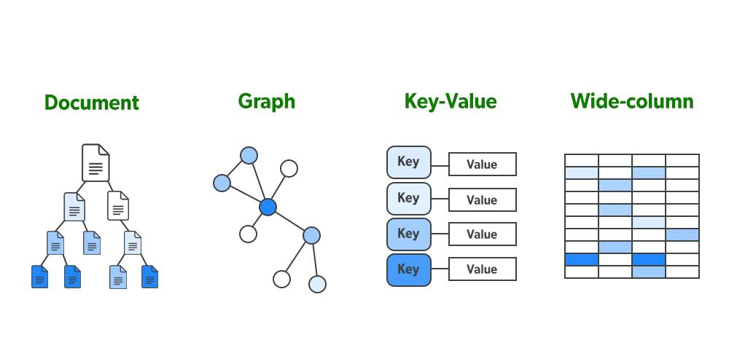
- Document Databases – Store data as JSON-like documents. (Example: MongoDB)
- Key-Value Stores – Store simple key–value pairs for fast lookups. (Example: Redis)
- Columnar Databases – Store data by columns for analytics. (Example: Apache Cassandra)
- Graph Databases – Store nodes & relationships for connected data. (Example: Neo4j)

ACID Properties
ACID stands for Atomicity, Consistency, Isolation, and Durability—four essential principles that ensure your database transactions are reliable, accurate, and secure.
- Atomicity: Ensures transactions complete fully or not at all.
- Consistency: Ensures the database moves from one valid state to another.
- Isolation: Ensures that multiple transactions can happen at the same time without affecting each other.
- Durability: Saves changes permanently after completion.

Real-World Applications of Databases
Databases are essential part of our life. There are several everyday activities that involve our interaction with databases.
- Banking: Stores transactions and account details.
- Transportation: Manages bookings and schedules.
- Education: Tracks student records and grades.
- Retail: Handles inventory and customer orders.
- Social Media: Stores user data, messages, and media.
- Multimedia: Manages images, audio, and video.
- Business & Data Science: Analyzes trends and supports predictions.

Importance of Databases for Different Technology
Databases are the engine behind every digital experience—whether you are building an app, training AI models, or running infrastructure at scale. Here is a breakdown of the most suitable database types for various technology domains:

1. Databases for Web Development
Web applications rely heavily on databases to store and manage user data, content, and transactions. Whether it is a blog or a large e-commerce platform, developers typically use:
- Popular Databases: MySQL, PostgreSQL, MongoDB, Firebase
- Use Case: Dynamic content, authentication, product catalogs

2. Databases for Mobile Development
Mobile apps require fast, lightweight databases optimized for limited device resources and offline access.
- Popular Databases: SQLite, Realm, Firebase Realtime DB
- Use Case: Local storage, syncing user preferences, offline-first apps

3. Databases for DevOps
DevOps teams manage CI/CD pipelines and infrastructure, where databases must support automation, monitoring, and scale.
- Popular Databases: PostgreSQL, Redis, InfluxDB, Cassandra
- Use Case: Logging, monitoring metrics, configuration storage

4. Databases for Data Engineering
Data engineers handle massive volumes and real-time pipelines. Their databases must be highly scalable and performant.
- Popular Databases: Apache Hadoop (HDFS), Apache Cassandra, Amazon Redshift, Google BigQuery
- Use Case: ETL processes, big data pipelines, real-time data streaming

5. Databases for Data Science
Data scientists need flexible querying, data aggregation, and easy integration with tools like Python and R.
- Popular Databases: PostgreSQL, MongoDB, Apache Hive, Snowflake
- Use Case: Feature extraction, exploratory analysis, modeling datasets

6. Databases for Artificial Intelligence
AI systems depend on structured, unstructured, and streaming data for model training and predictions.
- Popular Databases: MongoDB, Apache Cassandra, Google BigQuery, AWS S3 (data lake)
- Use Case: Storing training datasets, real-time inference, model feedback loops

7. Database for Cloud Computing
In cloud-native environments, databases must support autoscaling, high availability, and service integration.
- Popular Databases: Amazon Aurora, Google Cloud Spanner, Microsoft Azure Cosmos DB
- Use Case: SaaS platforms, distributed apps, serverless environments

8. Database for Blockchain/Web3.0
Blockchain-powered systems need tamper-proof, decentralized databases for trustless transactions and transparency.
- Popular Databases: BigchainDB, IPFS, Ethereum (as data ledger), Chainlink
- Use Case: Immutable ledgers, decentralized identity, smart contract data.

Difference between File System and DBMS

A file system and a DBMS are two kinds of data management systems that are used in different capacities and possess different characteristics. A File System is a way of organizing files into groups and folders and then storing them in a storage device. It provides the media that stores data as well as enables users to perform procedures such as reading, writing, and even erasure.
On the other hand, DBMS is a more elaborate software application that is solely charged with the responsibility of managing large amounts of structured data. It provides functionalities such as query, index, transaction, as well as data integrity. Although the file system serves well for the purpose of data storage for applications where data is to be stored simply and does not require any great organization, DBMS is more appropriate for applications where data needs to be stored and optimized for organizational and structural needs, security, etc.

File System
The file system is basically a way of arranging the files in a storage medium like a hard disk. The file system organizes the files and helps in the retrieval of files when they are required. File systems consist of different files which are grouped into directories. The directories further contain other folders and files. The file system performs basic operations like management, file naming, giving access rules, etc.
Example: NTFS(New Technology File System) , EXT(Extended File System).
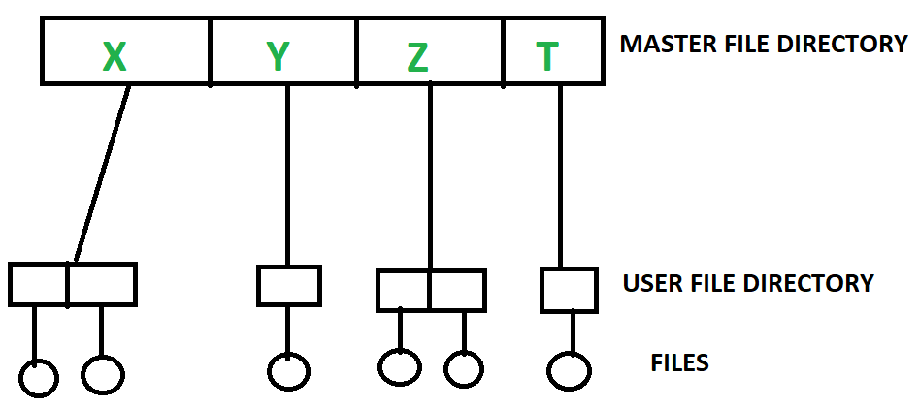File System

DBMS ( Database Management System)
Database Management System is basically software that manages the collection of related data. It is used for storing data and retrieving the data effectively when it is needed. It also provides proper security measures for protecting the data from unauthorized access. In Database Management System the data can be fetched by SQL queries and relational algebra. It also provides mechanisms for data recovery and data backup.
Example:
Oracle, MySQL, MS SQL server.
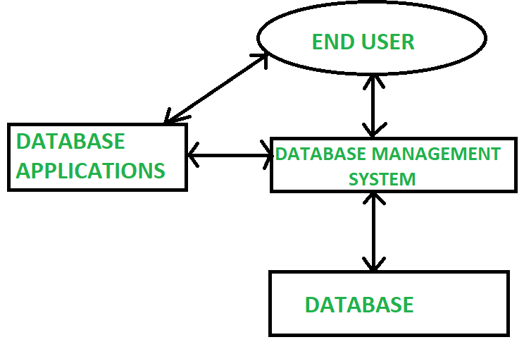DBMS

Difference Between File System and DBMS
Basics | File System | DBMS
Structure | The file system is a way of arranging the files in a storage medium within a computer. | DBMS is software for managing the database.
Data Redundancy | Redundant data can be present in a file system. | In DBMS there is no redundant data.
Backup and Recovery | It doesn't provide Inbuilt mechanism for backup and recovery of data if it is lost. | It provides in house tools for backup and recovery of data even if it is lost.
Query processing | There is no efficient query processing in the file system. | Efficient query processing is there in DBMS.
Consistency | There is less data consistency in the file system. | There is more data consistency because of the process of normalization .
Complexity | It is less complex as compared to DBMS. | It has more complexity in handling as compared to the file system.
Security Constraints | File systems provide less security in comparison to DBMS. | DBMS has more security mechanisms as compared to file systems.
Cost | It is less expensive than DBMS. | It has a comparatively higher cost than a file system.
Data Independence | There is no data independence. | In DBMS data independence exists, mainly of two types:  1) Logical Data Independence .  2)Physical Data Independence.
User Access | Only one user can access data at a time. | Multiple users can access data at a time.
Meaning | The users are not required to write procedures. | The user has to write procedures for managing databases
Sharing | Data is distributed in many files. So, it is not easy to share data. | Due to centralized nature data sharing is easy
Data Abstraction | It give details of storage and representation of data | It hides the internal details of Database
Integrity Constraints | Integrity Constraints are difficult to implement | Integrity constraints are easy to implement
Attribute s | To access data in a file , user requires attributes such as file name, file location. | No such attributes are required.
Example | Cobol , C++ | Oracle , SQL Server
A file system manages storage, while a DBMS provides efficient data management. To learn more, the GATE CS Self-Paced Course covers these differences thoroughly.
The main difference between a file system and a DBMS (Database Management System) is the way they organize and manage data.
- File systems are used to manage files and directories, and provide basic operations for creating, deleting, renaming, and accessing files. They typically store data in a hierarchical structure, where files are organized in directories and subdirectories. File systems are simple and efficient, but they lack the ability to manage complex data relationships and ensure data consistency.
- On the other hand, DBMS is a software system designed to manage large amounts of structured data, and provide advanced operations for storing, retrieving, and manipulating data. DBMS provides a centralized and organized way of storing data, which can be accessed and modified by multiple users or applications. DBMS offers advanced features like data validation, indexing , transactions, concurrency control , and backup and recovery mechanisms. DBMS ensures data consistency, accuracy, and integrity by enforcing data constraints, such as primary keys, foreign keys, and data types.
In summary, file systems are suitable for managing small amounts of unstructured data , while DBMS is designed for managing large amounts of structured data, and offers more advanced features for ensuring data integrity, security, and performance.

Conclusion
On balance, a File System focuses more on organizing, creating, storing, retrieving, renaming and deleting files at a storage device and mainly deals with fundamental levels of data operations. It is user-friendly and convenient for dealing with various files and directories but does not support complex data handling. In contrast, a DBMS is intended for comprehensive data storage, providing organization, efficient data access, and reliable information integrity. DBMS is appropriate for complex cases of data management, with many records that require storage, searching and updating.

Advantages of Database Management System
Last Updated : 12 Jul, 2025

Database Management System (DBMS) is a collection of interrelated data and a set of software tools/programs that access, process, and manipulate data. It allows access, retrieval, and use of that data by considering appropriate security measures and is really useful for better data integration and security.
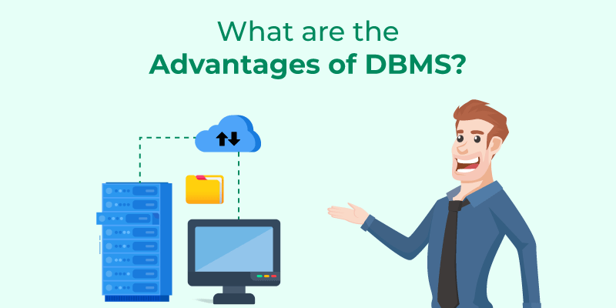Advantages of DBMS

Advantages of Database Management System
The advantages of database management systems are:
- Data Security: DBMS enhances data security through access control and encryption. It enforces privacy policies and prevents unauthorized access. As user numbers grow, it mitigates associated risks of breaches.
- Data integration: DBMS unifies data from different sources into a centralized system. This provides a coherent organizational view of operations. It helps to keep track of how one segment of the company affects another segment.
- Data abstraction: Since many complex algorithms are used by the developers to increase the efficiency of databases that are being hidden by the users through various data abstraction levels to allow users to easily interact with the system.
- Reduction in data Redundancy: DBMS avoids data duplication by enforcing unique constraints. It removes unnecessary repetitive entries in databases. This ensures efficient use of storage and improves consistency. for e.g. - If there are two same students in different rows, then one of the duplicate data will be deleted.
- Data sharing: A DBMS provides a platform for sharing data across multiple applications and users, which can increase productivity and collaboration.
- Data consistency and accuracy: DBMS enforces integrity constraints to maintain valid data. It minimizes discrepancies by syncing updates across all views. This reduces errors and ensures reliable & consistent data.
- Data organization: A DBMS provides a systematic approach to organizing data in a structured way, which makes it easier to retrieve and manage data efficiently.
- Efficient data access and retrieval: DBMS allows for efficient data access and retrieval by providing indexing and query optimization techniques which reduces time taken to retrieve large datasets. It boosts system performance and user satisfaction.
- Concurrency and maintained Atomicity: That means, if some operation is performed on one particular table of the database, then the change must be reflected for the entire database. The DBMS allows concurrent access to multiple users by using the synchronization technique.
- Scalability and flexibility: DBMS is highly scalable and can easily accommodate changes in data volumes and user requirements. It allows flexible schema modifications and expansion. This makes it ideal for dynamic organizational environments and can scale up or down depending on the needs of the organization.
DBMS offers numerous advantages, including data security, integrity, and reduced redundancy. If you're looking to master database concepts and their benefits, the GATE CS Self-Paced Course covers DBMS in a structured, easy-to-follow manner, ensuring you're exam-ready.

Advantages of Database Management System over Traditional File System
- Better Data Security: DBMS offers centralized control with advanced security features like encryption, authentication, and authorization.
It restricts unauthorized access and protects data from internal and external threats. This ensures sensitive information is kept secure and confidential. Compared to file systems, DBMS provides a much stronger security model.
- Reduced Data Redundancy: DBMS stores data in a centralized and structured way, minimizing duplication. It supports shared access across applications, eliminating repeated storage. Less redundancy means less storage use and fewer inconsistencies. File systems lack such control and often store duplicate data across files.

- Improved Data Consistency: Data consistency is maintained by enforcing validation rules and constraints. Changes in data reflect across all applications accessing it. This ensures uniformity of data for every user and use case. Traditional systems lack synchronization, causing discrepancies.

- Improved Data Access and Availability: DBMS provides efficient data access and retrieval mechanisms that enable quick and easy data access. It allows multiple users to access the data simultaneously, ensuring data availability.

- Improved Data Sharing: DBMS allows secure and simultaneous data sharing across users and systems. It supports real-time collaboration without conflict or data loss. Departments can interact seamlessly using a common data source. Traditional systems often require data duplication for sharing.

- Improved Data Integration: DBMS combines data from various sources into a unified view. It maintains integrity through referential, domain, and entity constraints. This enables accurate analysis and decision-making organization-wide. File systems struggle to integrate data from disparate platforms.

- Improved Data Backup and Recovery: DBMS offers automated, reliable backup and point-in-time recovery. Data can be restored after failures, maintaining consistency and availability. It supports disaster recovery strategies, ensuring business continuity. Traditional file systems often require manual, error-prone backups.

- Data independence: DBMS separates data’s logical structure from its physical storage. Users can access and manipulate data without knowing its location. This abstraction improves flexibility and reduces dependency on hardware/software changes. File systems tightly bind data to physical structure, limiting adaptability.

Conclusion
Overall, Database management System offers several advantages over traditional file-based systems. It ensures data integrity, security, and consistency, reduces data redundancy, and improves data access, sharing, and integration. These benefits make DBMS an essential tool for managing and processing data in modern organizations.

What is Data Abstraction in DBMS?
Last Updated : 23 Jul, 2025

Data Abstraction is one of the most important concepts in DBMS. Data abstraction is the process of hiding unwanted and irrelevant details from the end user. It helps to store information in such a way that the end user can access data which is necessary, the user will not be able to see what data is stored or how it is stored in a database.
- Data abstraction hides unwanted details, showing users only relevant data.
- It keeps data safe by hiding how and where data is stored.
- Abstraction simplifies access while maintaining data security and efficiency.
- For example, while buying clothes, users see only color, size, and brand, not production details.

Levels of Abstraction in DBMS
There are three levels of data abstraction in DBMS that are mentioned below:
- Physical or Internal level
- Logical or Conceptual level
- View or External level
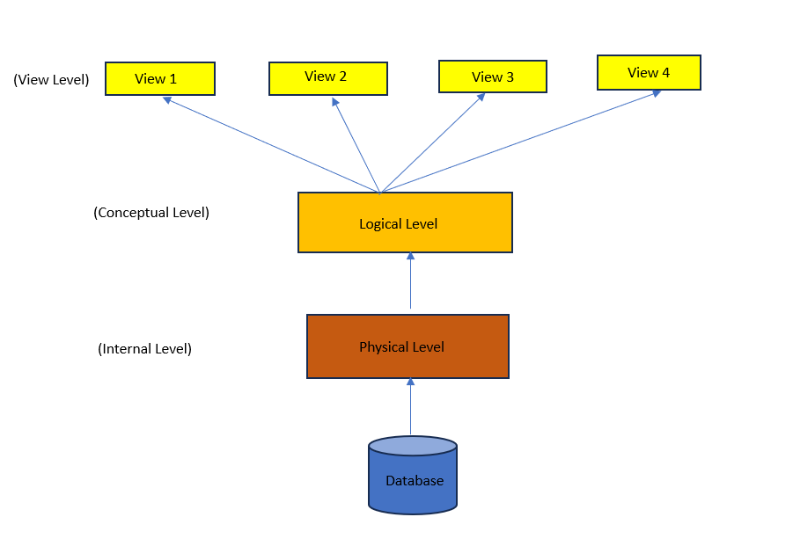
Data Abstraction levels in DBMS

Physical or Internal Level
It is the lowest level of data abstraction which defines how data is stored in database . It defines data structures used to store data and methods to access data in database. It is very complex to understand and hence kept hidden from user. Database administrator decides how and where to store the data in database.
Physical level deals with actual storage details like data organization, disk space allocation and data access methods.

Logical or Conceptual Level
It is intermediate level present next to physical level. It defines what data is present in database and their relationships between them . It is less complex as compared to physical level. Programmers generally work at this level and depending on data, structure of tables, relationships and their constraints is decided at this level.

View or External Level
It is the highest level in abstraction. There are different levels of views and each view defines only a part of whole data required to user. This level defines many views of same database for simplification of view to user. This is the highest level and easiest to understand for user.

Introduction of 3-Tier Architecture in DBMS
Last Updated : 23 Jul, 2025

The 3-Tier Architecture is one of the most popular and effective architectural models in the design and development of modern database-driven applications. It is widely used in Database Management Systems (DBMS) for organizing and managing complex data interactions across various layers of an application. Whether you're building a scalable enterprise application or a responsive web service, understanding 3-Tier Architecture is crucial for efficient system design and management.
In this article, we will explain the details of the 3-Tier Architecture in DBMS, explaining each of its components, the role it plays in application development, and the key benefits it offers for building robust, secure, and maintainable systems.

What is 3 Tier Architecture in DBMS?
In DBMS, the 3-tier architecture is a client-server architecture that separates the user interface, application processing, and data management into three distinct tiers or layers. The 3-tier architecture is widely used in modern web applications and enterprise systems because it offers scalability, flexibility, and security. Here is a brief description of each tier in the 3-tier architecture:
- Presentation Tier (User Interface Layer)
- Application Tier (Business Logic Layer)
- Data Management Tier (Database Layer)
This separation of concerns allows for easier maintenance, scalability, and flexibility in system design, enabling developers to work independently on each layer without disturbing the others.
3rd tier Architecture

Components of the 3-Tier Architecture

1. Presentation Tier (User Interface Layer)
The presentation tier is the user interface or client layer of the application. It is responsible for presenting data to the user and receiving input from the user. This tier communicates with the Application Tier to process user requests and display relevant information. This tier can be a web browser, mobile app, or desktop application.
- What It Does: It ensures the application is user-friendly by providing interfaces such as web browsers, mobile apps, or desktop applications.
- Example: If you’re using a banking app, the presentation tier would display your account balance, allow you to make transfers, and display results based on your actions.

Why it is Important?
- The Presentation Layer focuses purely on the user interface, ensuring smooth interactions and enhancing user experience (UX).
- It abstracts the business logic and data management complexities, making the system more user-friendly.

2. Application Tier ( Business Logic Layer)
The application tier is the middle layer of the 3-tier architecture. It acts as the intermediary between the Presentation Tier and the Data Management Tier. It is responsible for processing and managing the business logic of the application. This tier communicates with the presentation tier to receive user input and communicates with the data management tier to retrieve or store data. This tier may include application servers, web servers, or APIs.
- What It Does: It houses the application's core functionality, such as calculating values, applying rules, handling workflows, etc.
- Example: If you're purchasing an item through an e-commerce platform, the Application Layer handles all the logic like verifying available stock, applying discounts, calculating taxes, and confirming your payment method.

Why is it Important?
- It decouples the core business logic from the user interface, making it easier to change or update business rules without affecting the user-facing part of the application.
- This tier allows for better management of application workflows and business decisions

3. Data Management Tier ( Database Layer)
The Data Management tier is the bottom layer of the 3-tier architecture. It is responsible for managing and storing data. This tier can include databases, data warehouses, or any other persistent data storage solution. The data management tier communicates with the application tier save, retrieve, or manipulate data according to the business logic.
- What It Does: It ensures that the data is safely stored, retrieved, and maintained. It handles the database connections and ensures data integrity.
- Example: In a customer relationship management (CRM) system, this tier would store customer details, transaction history, and other data relevant to the business.

Why is it Important?
- This layer ensures data consistency, security, and integrity. By abstracting the database layer from the application logic, it allows developers to modify database structures without impacting the overall application functionality.
- It is also where optimizations like indexing, data replication, and data security are handled.

Why Choose 3-Tier Architecture?
The 3-tier architecture in DBMS provides several advantages for developers and organizations working on large-scale, database-driven applications. Here are a few key benefits:
1. Scalability: The separation of the three tiers allows each layer to scale independently. For instance, if the number of users increases, you can scale the Presentation Tier by adding more web servers, or you can enhance the Data Management Tier by optimizing or adding additional databases without affecting the Application Tier.
2. Flexibility: Each layer is loosely coupled, meaning you can modify or upgrade any of the layers without disrupting the others. For example, you could swap out the database system in the Data Management Tier (e.g., from MySQL to PostgreSQL) without affecting the business logic or user interface layers.
3. Security: By isolating the Data Management Tier, you can enforce better security practices, such as restricting direct access to the database and protecting sensitive data. The Presentation Tier and Application Tier interact via secure APIs or middleware, reducing the risk of unauthorized access.
4. Maintainability: Because the architecture is modular, it’s easier to maintain and update. If you need to change the user interface or tweak the business logic, these changes won’t require touching the underlying data storage or database. The separation of concerns also means that developers can specialize in one of the layers (frontend, backend, or database), allowing for more focused development and faster updates.
5. Improved Performance: The layered approach improves system performance by ensuring that each tier is optimized for its specific function. For instance, database queries in the Data Management Tier can be optimized independently, and the Application Tier can focus on processing requests efficiently.

3-Tier Schema Architecture in DBMS
In DBMS, the 3-Tier Schema Architecture refers to how the data is logically and physically organized in three layers:
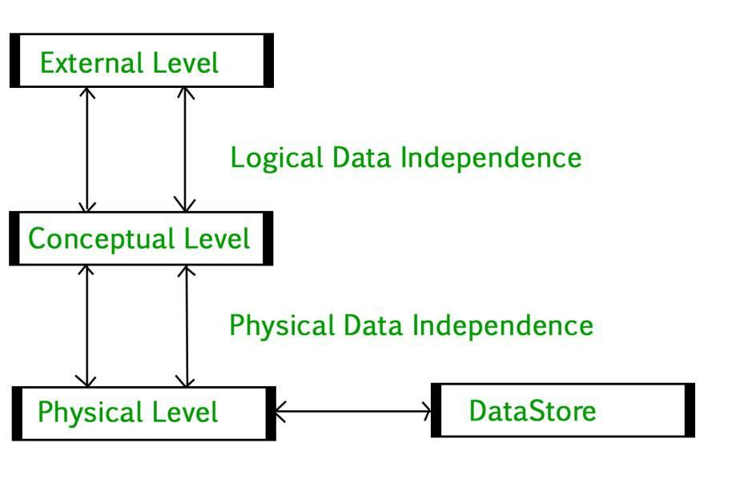3-Tier Schema Architecture in DBMS

1. Physical Level
At the physical level, the information about the location of database objects in the data store is kept. Various users of DBMS are unaware of the locations of these objects.In simple terms,physical level of a database describes how the data is being stored in secondary storage devices like disks and tapes and also gives insights on additional storage details.

2. Conceptual Level
At conceptual level, data is represented in the form of various database tables. For Example, STUDENT database may contain STUDENT and COURSE tables which will be visible to users but users are unaware of their storage.Also referred as logical schema,it describes what kind of data is to be stored in the database.

3. External Level
An external level specifies a view of the data in terms of conceptual level tables. Each external level view is used to cater to the needs of a particular category of users. For Example, FACULTY of a university is interested in looking course details of students, STUDENTS are interested in looking at all details related to academics, accounts, courses and hostel details as well. So, different views can be generated for different users. The main focus of external level is data abstraction.

Conclusion
In conclusion, a Database Management System (DBMS) employs the 3-Tier Architecture, a tried-and-true structure that separates an application into three main layers: Presentation, Application Logic, and Data. This architectural technique is increasingly popular for creating dependable and maintainable software systems that communicate with databases because it improves the modularity, scalability, security, reusability, and flexibility of applications.

Physical and Logical Data Independence
Last Updated : 15 Jul, 2025

Data independence refers to the ability to change the schema (structure) at one level without affecting the schema at higher or lower levels in the DBMS architecture. It ensures that changes in the data storage and structure do not impact the overall functioning or application programs using the database.
There are two key types of data independence:
- Physical Data Independence
- Logical Data Independence
These two types help make databases more flexible and easier to manage over time by minimizing the impact of changes at various levels. There are 3 levels in the schema architecture of DBMS: Physical level, Logical level, and View level (lowest to highest level).
Data Independence

Physical Data Independence
Physical Data Independence is defined as the ability to make changes in the structure of the lowest level of the DBMS without affecting the higher-level schemas. Hence, modification in the Physical level should not result in any changes in the Logical or View levels.

Key Features
- Changes in physical storage (e.g., creating new files, adding indexes, storing data in a different location) should not impact the higher-level schemas.
- It ensures optimization of database performance without affecting the overall structure or user applications.
Example: Suppose we want to improve database performance by creating a new index for faster retrieval of data or adding a new file system for storage. These modifications should not affect the logical view of the data, such as how the data is represented in the database tables or how it is accessed by the us

How is Physical Data Independence Achieved?
Physical Data Independence is achieved by ensuring that the mapping between the physical level and the logical level (PL-LL mapping) is abstracted. Changes made to the physical layer should not require any changes in the logical schema or the view layer.
This abstraction helps in maintaining stability in the database's logical representation, even when performance optimization techniques are applied.

Logical Data Independence
Logical Data Independence is the ability to change the logical schema (the structure and relationships of the data) without affecting the view schema or application programs. This means that changes at the logical level should not require modifications at the user interface or application programs that interact with the database.

Key Features
- Changes in logical schema (e.g., adding or deleting attributes, creating new relationships) should not require changes at the higher-level view schema or application programs.
- It allows the database structure to evolve over time without affecting how users interact with the data.
Example:
Logical Changes: Consider adding a new column to a database table (e.g., adding an "email" column to the "employees" table). If the modification does not require any changes to the way users interact with the data, this is an example of logical data independence.
Impact on Application Programs: Ideally, application programs or views accessing this table should not need to change, even if the database schema has been modified.

How is Logical Data Independence Achieved?
Logical Data Independence is achieved by ensuring that the view layer to logical layer mapping (VL-LL mapping) is well-defined and flexible. Changes to the logical schema, such as adding or removing attributes or changing data structures, should not require changes in how the data is presented to users. This abstraction helps maintain compatibility with applications that rely on the database.

Why is Data Independence Important?

1. Flexibility in Database Design
Data independence allows for changes to be made at one level of the database without affecting the other levels. This provides flexibility in database management and design, making it easier to optimize storage or modify data representations without disrupting the entire system.

2. Reduces Maintenance Effort
With proper data independence, database administrators can make necessary changes to improve performance, add new features, or correct issues without needing to update application programs or interfaces. This reduces the maintenance efforts required as the database evolves.

3. Compatibility with Application Programs
Both Physical and Logical Data Independence help ensure that application programs remain unaffected by changes in the database structure. As a result, users and developers can continue to use and interact with the database without worrying about breaking existing code or interfaces.

4. Long-Term Sustainability
Data independence makes it easier to maintain and scale databases in the long term. As organizations grow and their data needs evolve, the database schema can be changed, optimized, and expanded without disrupting business operations or user interactions

MULTIPLE CHOICE QUESTIONS PRACTICE

1
A database is best defined as:
A. Collection of programs
B. Organized collection of related data
C. Random data stored in files
D. Collection of tables only
Answer: B

2
Which software manages databases?
A. Compiler
B. Operating System
C. DBMS
D. Interpreter
Answer: C

3
Which of the following is an example of a database?
A. Telephone directory
B. Text editor
C. Calculator
D. Keyboard
Answer: A

4
Which system stores data in separate application files?
A. DBMS
B. File System
C. Operating System
D. Data Warehouse
Answer: B

5
Which problem occurs frequently in file systems?
A. Data redundancy
B. Encryption
C. Indexing
D. Query optimization
Answer: A

6
DBMS reduces:
A. Data redundancy
B. Data storage
C. CPU cycles
D. RAM usage
Answer: A

7
Data abstraction mainly helps to:
A. Hide implementation details
B. Increase redundancy
C. Increase file size
D. Remove tables
Answer: A

8
The highest level of data abstraction is:
A. Internal level
B. Conceptual level
C. External level
D. Physical level
Answer: C

9
Which level describes how data is actually stored?
A. External
B. Conceptual
C. Internal
D. Logical
Answer: C

10
Which level describes what data is stored in the database?
A. Conceptual
B. Internal
C. Physical
D. Device
Answer: A

11
Which architecture is used in DBMS?
A. Two schema architecture
B. Three schema architecture
C. Four schema architecture
D. Five schema architecture
Answer: B

12
Which level shows user views?
A. Internal
B. Conceptual
C. External
D. Physical
Answer: C

13
Logical data independence means:
A. Changing conceptual schema without changing external schema
B. Changing internal schema without changing conceptual schema
C. Changing DBMS software
D. Changing database users
Answer: A

14
Physical data independence means:
A. Changing conceptual schema
B. Changing storage structures without affecting conceptual schema
C. Removing DBMS
D. Changing users
Answer: B

15
Which problem occurs when the same data appears multiple times?
A. Redundancy
B. Security
C. Integrity
D. Recovery
Answer: A

16
DBMS provides:
A. Data security
B. Data integrity
C. Backup
D. All of the above
Answer: D

17
Which layer hides storage details from users?
A. Data abstraction
B. Query processing
C. Indexing
D. Normalization
Answer: A

18
Conceptual schema mainly represents:
A. Logical structure of database
B. Physical storage
C. User interface
D. File system
Answer: A

19
Which system has program-data dependence?
A. DBMS
B. File system
C. Data warehouse
D. Data lake
Answer: B

20
Which level interacts directly with storage devices?
A. Internal level
B. External level
C. Conceptual level
D. Logical level
Answer: A

21
Which problem occurs due to duplicate data stored in multiple files?
A. Data inconsistency
B. Data abstraction
C. Data security
D. Data modeling
Answer: A

22
Which of the following is NOT an advantage of DBMS?
A. Reduced redundancy
B. Improved security
C. Program-data dependence
D. Data sharing
Answer: C

23
Which schema describes overall database structure?
A. External schema
B. Conceptual schema
C. Internal schema
D. View schema
Answer: B

24
In three schema architecture:
External schemas are mapped to:
A. Internal schema
B. Conceptual schema
C. Storage devices
D. File system
Answer: B

25
Conceptual schema is independent of:
A. Physical storage
B. Logical structure
C. Entities
D. Relationships
Answer: A

26
Which independence is harder to achieve?
A. Logical independence
B. Physical independence
C. Both equal
D. None
Answer: A

27
Which level includes indexes and hashing structures?
A. Internal level
B. External level
C. Conceptual level
D. Logical level
Answer: A

28
External schema mainly supports:
A. Multiple user views
B. Storage structures
C. Query optimization
D. Transaction management
Answer: A

29
Which layer hides conceptual schema complexity from users?
A. External schema
B. Internal schema
C. Physical schema
D. File system
Answer: A

30
Which mapping exists between conceptual and internal levels?
A. Conceptual–Internal mapping
B. Logical–Physical mapping
C. External–Internal mapping
D. User–DB mapping
Answer: A

31
File systems suffer from:
A. Data redundancy
B. Data inconsistency
C. Security issues
D. All of the above
Answer: D

32
Which abstraction level describes relations, attributes, constraints?
A. Conceptual
B. Internal
C. External
D. Physical
Answer: A

33
Which of the following is stored at internal level?
A. Records
B. Index structures
C. File organization
D. All of the above
Answer: D

34
External schema corresponds to:
A. User view
B. Logical view
C. Physical view
D. Storage view
Answer: A

35
DBMS mainly improves:
A. Data sharing
B. Data consistency
C. Security
D. All
Answer: D

36
Logical data independence protects:
A. Applications
B. Storage structures
C. Disk layout
D. Memory
Answer: A

37
Which level describes entities and relationships?
A. Conceptual
B. Internal
C. External
D. Device
Answer: A

38
Which schema changes frequently for performance tuning?
A. Internal schema
B. External schema
C. Conceptual schema
D. Logical schema
Answer: A

39
Which abstraction level interacts with DBAs?
A. Conceptual
B. Internal
C. External
D. None
Answer: A

40
Which schema describes subset of database for a user?
A. External schema
B. Internal schema
C. Conceptual schema
D. Physical schema
Answer: A

- DBMS provides centralized control of data
Answer: True → A
- Program-data independence is achieved using
Answer: Data abstraction
- Which schema hides physical storage details?
Answer: Conceptual schema
- Physical independence mainly concerns
Answer: Internal schema changes
- External schema may represent
Answer: Different user views
- Internal schema focuses on
Answer: Storage structures
- Conceptual schema defines
Answer: Entire logical database
- Mapping between external and conceptual schema is called
Answer: External–Conceptual mapping
- Data independence is achieved through
Answer: Three schema architecture
- DBMS removes problem of
Answer: Program data dependence

51
In three schema architecture:
Number of conceptual schemas is:
A. Many
B. One
C. Zero
D. Two
Answer: B

52
If a new attribute is added to a relation but user views remain unchanged, this demonstrates:
A. Logical independence
B. Physical independence
C. View independence
D. Storage independence
Answer: A

53
Which level is affected when index structures change?
A. External
B. Conceptual
C. Internal
D. Logical
Answer: C

54
If DBMS changes from heap file to B+ tree storage but applications remain unchanged, which property holds?
A. Logical independence
B. Physical independence
C. Schema independence
D. Program independence
Answer: B

55
External schemas are also called:
A. Views
B. Tables
C. Files
D. Relations
Answer: A

56
Which schema includes data types and constraints?
Answer: Conceptual schema

57
Logical data independence is difficult because:
A. External schemas depend on conceptual schema
B. Storage changes frequently
C. DBMS is complex
D. Hardware limitations
Answer: A

58
Internal schema is mainly concerned with:
A. Disk blocks
B. File organization
C. Index structures
D. All
Answer: D

59
Which mapping ensures logical data independence?
Answer: External–Conceptual mapping

60
Which layer is closest to physical storage?
Answer: Internal schema

1
Which are advantages of DBMS?
A. Data security
B. Data redundancy
C. Data integrity
D. Backup
Answer: A C D

2
Which are DBMS abstraction levels?
A. External
B. Conceptual
C. Internal
D. Physical
Answer: A B C

3
Which problems occur in file systems?
A. Redundancy
B. Inconsistency
C. Security issues
D. Query optimization
Answer: A B C

4
External schema provides:
A. User specific views
B. Data hiding
C. Physical storage
D. Security
Answer: A B D

5
Internal schema contains:
A. Indexes
B. File structures
C. Disk blocks
D. User views
Answer: A B C

6
Conceptual schema defines:
A. Entities
B. Relationships
C. Constraints
D. Disk blocks
Answer: A B C

7
Which changes demonstrate physical data independence?
A. Changing index structure
B. Changing file organization
C. Changing attribute names
D. Changing disk layout
Answer: A B D

8
Which changes require logical data independence?
A. Adding attribute
B. Removing relation
C. Splitting table
D. Changing file organization
Answer: A B C

9
Three schema architecture ensures:
A. Data abstraction
B. Data independence
C. Multiple views
D. Query optimization
Answer: A B C

10
Which components belong to internal schema?
A. Hash structures
B. B+ trees
C. File organization
D. User views
Answer: A B C

